Java Concurrency Fork Join Pool

# Fork Join pool

ForkJoinPool was introduced in Java 7. Same is similar to **Executor framework**but with one difference. Forkjoin pool acts in recursive way unlike Executor thread, Executor thread splits the bigger task then submit task to worker threads. ForkJoin pool takes a big task then

Split into smaller tasks again those smaller tasks splits themselves to  sub tasks until each sub-task is atomic or not divisible.  So it work’s recursively.

Pictorial view to understand ForkJoin pool concept.

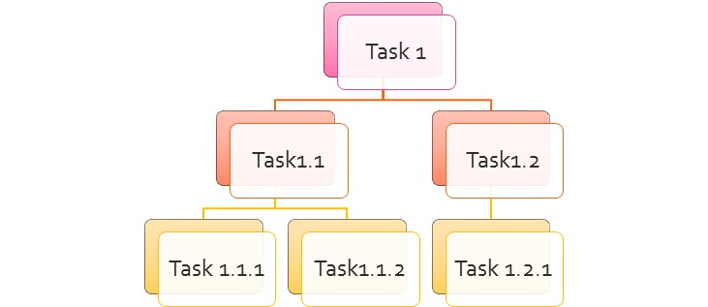

Divide bigger task in to smaller tasks

Fork: To split the sub-tasks from Bigger task. Ex: Task 1.1 splits to Task 1.1.1 and Task 1.1.2

Join: Getting result from immediate sub-tasks. Ex: Task 1.1 take results from Task 1.1.1 and Task 1.1.2

Fork Join pool is faster than Executor service.

Fork join Vs Executor service.

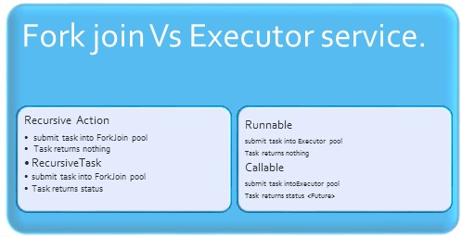

Example:

Suppose we want search an element in a sorted array. So we will use

 Binary Search Algorithm.

Our Search Algorithm:

Step 1:   Determines the mid element of the array, check mid element equals with search element if so return else split array in to two halves based on mid element.

Step 2: If search element is less than mid element then we create a new subtask in this sub task we take left half of the array.

Step 3: If element is greater than mid element then we create a new subtask in this sub task we take right half of the array.

Step 4: Until element is not found we continue the step 4 and 5.

Step 5: If array size is 1 and array element is not equal to search element. returns Element Not Found.

**package** com.example.concurrency;

**import** java.util.Arrays;

**import** java.util.concurrent.RecursiveTask;

**public** **class** ForkJoinSearcher **extends** RecursiveTask<Boolean>{

**int**[] arr;

**int** searchableElement;

ForkJoinSearcher(**int**[] arr,**int** search)

{

**this**.arr = arr;

**this**.searchableElement=search;

}

@Override

**protected** Boolean compute() {

**int** mid=( 0 + arr.length)/2;

System.***out***.println(Thread.*currentThread*().getName() + " says : After splliting the arry length is :: "+ arr.length + " Midpoint is " + mid);

**if**(arr[mid]==searchableElement)

{

System.***out***.println(" FOUND !!!!!!!!!");

**return** **true**;

}

**else** **if**(mid==1 || mid == arr.length)

{

System.***out***.println("NOT FOUND !!!!!!!!!");

**return** **false**;

}

**else** **if**(searchableElement < arr[mid])

{

System.***out***.println(Thread.*currentThread*().getName() + " says :: Doing Left-search");

**int**[] left = Arrays.*copyOfRange*(arr, 0, mid);

ForkJoinSearcher forkTask = **new** ForkJoinSearcher(left,searchableElement);

forkTask.fork();

**return** forkTask.join();

}

**else** **if**(searchableElement > arr[mid])

{

System.***out***.println(Thread.*currentThread*().getName() + " says :: Doing Right-search");

**int**[] right = Arrays.*copyOfRange*(arr, mid, arr.length);

ForkJoinSearcher forkTask = **new** ForkJoinSearcher(right,searchableElement);

forkTask.fork();

**return** forkTask.join();

}

**return** **false**;

}

}

**package** com.example.concurrency;

**import** java.util.Arrays;

**import** java.util.concurrent.ForkJoinPool;

**public** **class** BinarySearch {

**int**[] arr = **new** **int**[100];

**public** BinarySearch()

{

init();

}

**private** **void** init()

{

**for**(**int** i=0; i<arr.length;i++)

{

arr[i]=i;

}

Arrays.*sort*(arr);

}

**public** **void** createForJoinPool(**int** search)

{

ForkJoinPool forkJoinPool = **new** ForkJoinPool(50);

ForkJoinSearcher searcher = **new** ForkJoinSearcher(**this**.arr,search);

Boolean status = forkJoinPool.invoke(searcher);

System.***out***.println(" Element ::" + search +" has been found in array? :: " + status );

}

**public** **static** **void** main(String[] args) {

BinarySearch search = **new** BinarySearch();

search.createForJoinPool(10);

System.***out***.println("**********************");

search.createForJoinPool(104);

}

}

Output :

ForkJoinPool-1-worker-57 says : After splliting the arry length is :: 100 Midpoint is 50

ForkJoinPool-1-worker-57 says :: Doing Left-search

ForkJoinPool-1-worker-57 says : After splliting the arry length is :: 50 Midpoint is 25

ForkJoinPool-1-worker-57 says :: Doing Left-search

ForkJoinPool-1-worker-50 says : After splliting the arry length is :: 25 Midpoint is 12

ForkJoinPool-1-worker-50 says :: Doing Left-search

ForkJoinPool-1-worker-57 says : After splliting the arry length is :: 12 Midpoint is 6

ForkJoinPool-1-worker-57 says :: Doing Right-search

ForkJoinPool-1-worker-50 says : After splliting the arry length is :: 6 Midpoint is 3

ForkJoinPool-1-worker-50 says :: Doing Right-search

ForkJoinPool-1-worker-43 says : After splliting the arry length is :: 3 Midpoint is 1

FOUND !!!!!!!!!

Element ::10 has been found in array? :: true

**********************

ForkJoinPool-2-worker-57 says : After splliting the arry length is :: 100 Midpoint is 50

ForkJoinPool-2-worker-57 says :: Doing Right-search

ForkJoinPool-2-worker-57 says : After splliting the arry length is :: 50 Midpoint is 25

ForkJoinPool-2-worker-57 says :: Doing Right-search

ForkJoinPool-2-worker-50 says : After splliting the arry length is :: 25 Midpoint is 12

ForkJoinPool-2-worker-50 says :: Doing Right-search

ForkJoinPool-2-worker-57 says : After splliting the arry length is :: 13 Midpoint is 6

ForkJoinPool-2-worker-57 says :: Doing Right-search

ForkJoinPool-2-worker-50 says : After splliting the arry length is :: 7 Midpoint is 3

ForkJoinPool-2-worker-50 says :: Doing Right-search

ForkJoinPool-2-worker-57 says : After splliting the arry length is :: 4 Midpoint is 2

ForkJoinPool-2-worker-57 says :: Doing Right-search

ForkJoinPool-2-worker-43 says : After splliting the arry length is :: 2 Midpoint is 1

NOT FOUND !!!!!!!!!

Element ::104 has been found in array? :: false